**Data Testing Assessment**

A school 'Study & Play' has different branches in India. Students appeared in 10th & 12th board have scored good marks in different subjects. 'Study & Play' wants to recognize teachers across different streams to award them for their student's performance.

'Student & Play' are looking for a data warehouse solution to do analysis on student performance in a particular branch or subject.

**Exercise -**

As a part of this exercise, use the below Student data to import in database table.

Sample Data –

|  |  |  |  |  |
| --- | --- | --- | --- | --- |
| Student Name | StudentRollNo | Class | Age | Father's Name |
| AJAY KUMAR | IETLINF01 | X | 16 | PREM KUMAR |
| RAJAT MISHRA | IETLINF02 | XI | 17 | PANKAJ MISHRA |
| SUDHEER SHARMA | IETLINF03 | IX | 15 | SUNDER SHARMA |
| NANCY KAUR | IETLINF04 | XII | 18 | AK SINGH |
| SUMITA SHARMA | IETLINF05 | IV | 14 | AJAY SHARMA |
| NANDINI GUPTA | IETLINF06 | VII | 18 | RAM GUPTA |
| RAM KUMAR | IETLINF07 | X | 16 | RAMAN KUMAR |

Tasks

1. Create above table in database and insert the data.
2. Write sql query to find out total number of students in each class.
3. Write sql query to find out average age of students in each class.
4. Write sql query to find out the number of students having same roll no.
5. Write sql query to view the duplicate name of a student from the table.

Assignment:

Logged in <https://livesql.oracle.com/>

1. Create above table in database and insert the data.

Created the below Student table:

CREATE TABLE STUDENT

(

STU_ROLLNO NVARCHAR2(9) PRIMARY KEY,

STU_NAME NVARCHAR2(30) NOT NULL,

STU_CLASS NVARCHAR2(4) ,

STU_AGE NUMBER(10) CHECK(STU_AGE between 2 and 20),

STU_FATHERNAME NVARCHAR2(30)

);

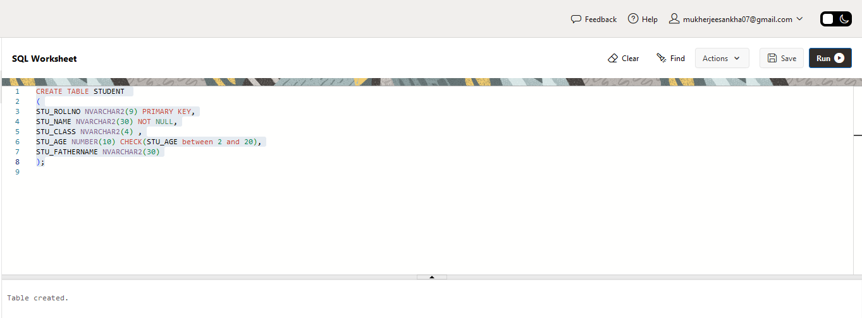

Check the table structure:

DESC STUDENT;

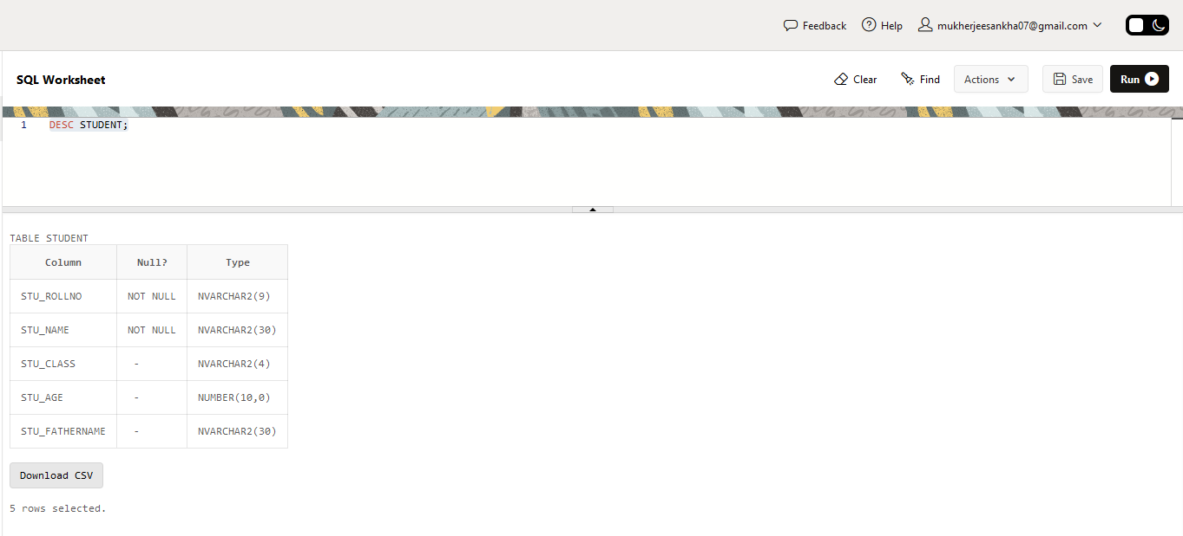

Insert the below values in STUDENT table:

INSERT INTO STUDENT VALUES (‘IETLINF01’,’AJAY KUMAR’,’X’,16,’PREM KUMAR’);

INSERT INTO STUDENT VALUES (‘IETLINF02’,’RAJAT MISHRA’,’XI’,17,’PANKAJ MISHRA’);

INSERT INTO STUDENT VALUES (‘IETLINF03’,’SUDHEER SHARMA’,’IX’,15,’SUNDER SHARMA’);

INSERT INTO STUDENT VALUES (‘IETLINF04’,’NANCY KAUR’,’XII’,18,’AK SINGH’);

INSERT INTO STUDENT VALUES (‘IETLINF05’,’SUMITA SHARMA’,’IV’,14,’AJAY SHARMA’);

INSERT INTO STUDENT VALUES (‘IETLINF06’,’NANDINI GUPTA’,’VII’,18,’RAM GUPTA’);

INSERT INTO STUDENT VALUES (‘IETLINF07’,’RAM KUMAR’,’X’,16,’RAMAN KUMAR’);

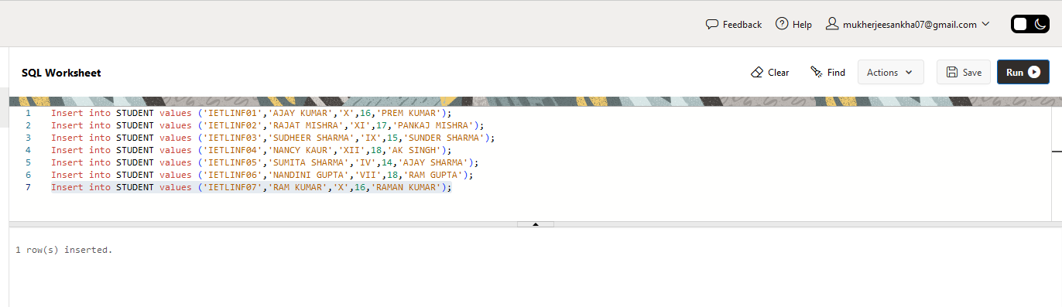

Show all Student data:

SELECT * FROM STUDENT;

1. Write sql query to find out total number of students in each class.

SELECT DISTINCT STU_CLASS "CLASS", COUNT(*) "TOTAL STUDENT" FROM STUDENT GROUP BY STU_CLASS;

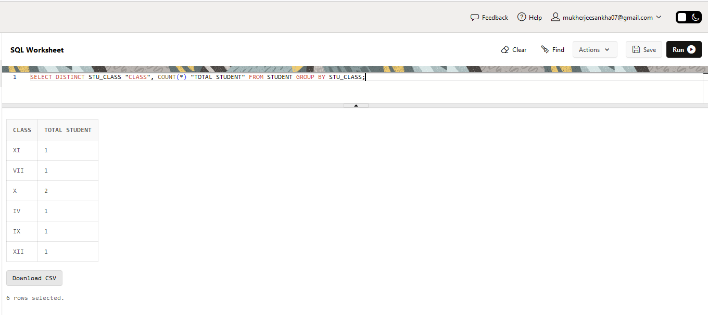

1. Write sql query to find out average age of students in each class.

SELECT DISTINCT STU_CLASS "CLASS", AVG(STU_AGE) "AVERAGE AGE" FROM STUDENT GROUP BY STU_CLASS;

1. Write sql query to find out the number of students having same roll no.

For running the above query, the Primary Key constraint has to be removed from STUDENT table.

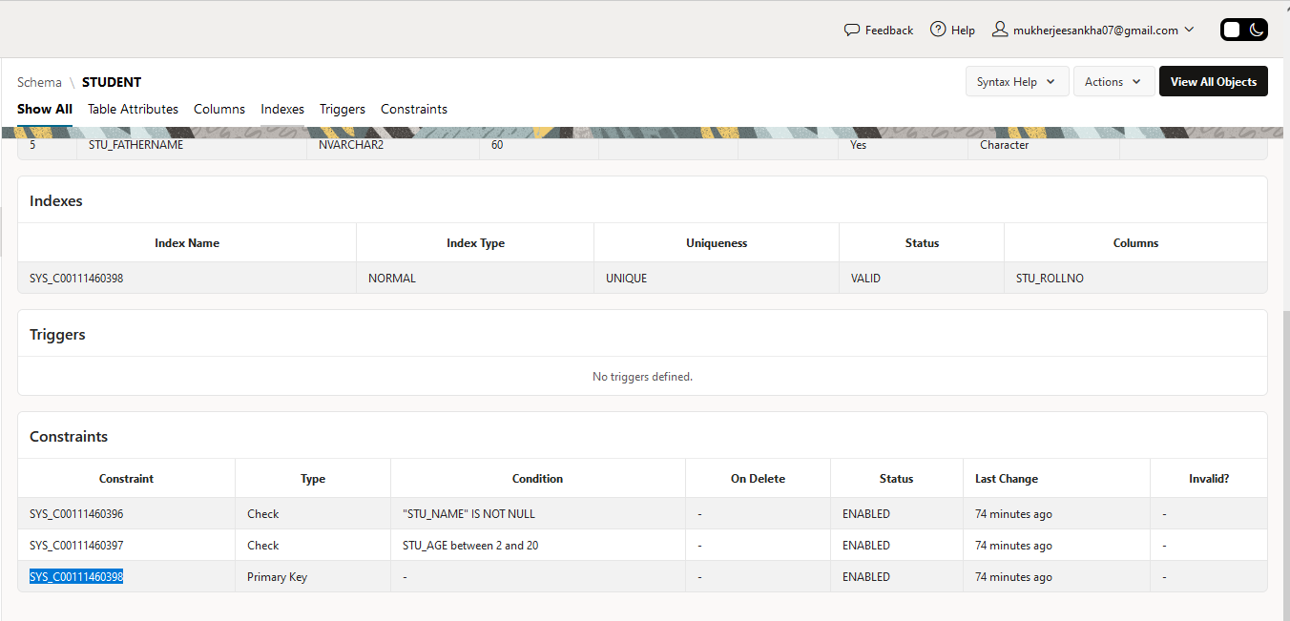

ALTER TABLE STUDENT DROP CONSTRAINT SYS_C00111460398;

Added the NOT NULL Constraint to STU_ROLLNO.

ALTER TABLE STUDENT MODIFY STU_ROLLNO NOT NULL;

Inserted a duplicate Roll No ‘IETLINF04’ to get result of duplicate search query:

INSERT INTO STUDENT VALUES (‘IETLINF04’,’RITA SEN’,’X’,16,’PALLAB SEN’);

SELECT STU_ROLLNO, COUNT(*) FROM STUDENT

GROUP BY STU_ROLLNO

HAVING COUNT(*) > 1;

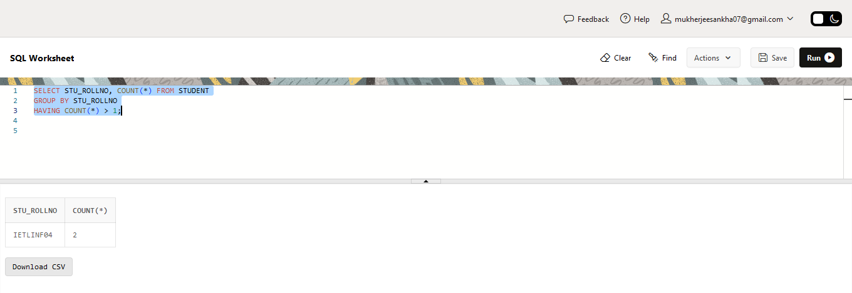

1. Write sql query to view the duplicate name of a student from the table.

To get the above result, a duplicate student name is inserted into the table.

INSERT INTO STUDENT VALUES (‘IETLINF08’,’RITA SEN’,’VIII’,14,’ARNAB SEN’);

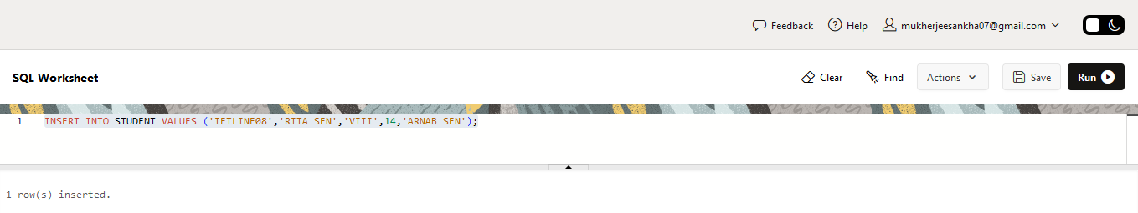

SELECT STU_NAME, COUNT(STU_NAME) FROM STUDENT

GROUP BY STU_NAME

HAVING COUNT(STU_NAME) > 1;

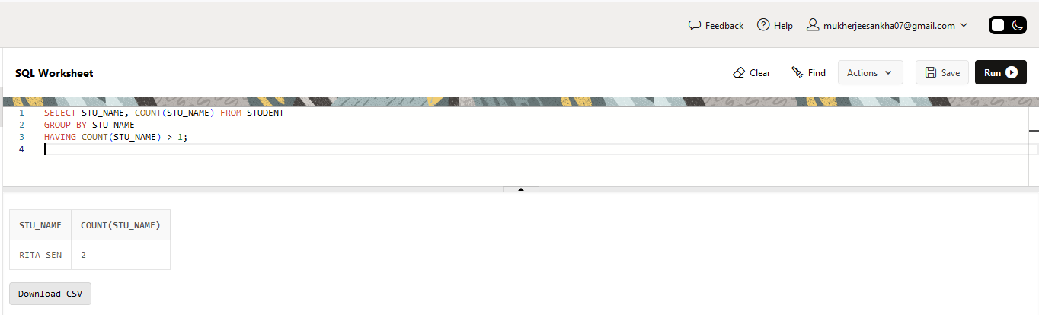

******************* END *******************